
C PROGRAMMING ASSIGNMENT
Student Submission Template

Student Name | R ROHITHKUMAR
Register Number | 1911260135
Course Code & Name | CSA-0211/_C-Programming
Slot | Slot D
Assignment / Task Title | 2
GitHub Repository URL | https://github.com/Rohith45-ultra/CSA0211-1911260135-Cprogramming.git
Submission Date | 5/11/2026
Instructions to Students
- Complete every section for each assigned task.
- Write your own explanation, algorithm/pseudocode, and program.
- Run the program and insert a clear screenshot of the output.
- Include test cases and a short analysis where applicable.
- If code is maintained on GitHub, provide the correct repository link

TASK 7 — Diagnose, Redesign and Validate (13 Marks)
Bloom's Level: K5 – Evaluate

Task / Problem Statement
Review one earlier program and select a significant limitation that becomes important as the input size grows. Diagnose the bottleneck, define a measurable objective, redesign the solution and compare both versions using the same inputs.

Aim
To improve the prime-ticket verification program from Q5 by reducing repeated divisor checks while preserving correct prime results.

Concept / Theory
The original method checks every possible divisor from 2 to n-1. The improved trial-division method uses the mathematical fact that a composite number has a divisor no greater than its square root. This reduces the number of modulo operations without requiring a large lookup array.

Procedure / Algorithm
- Measure the division count of the original method for the same ticket numbers.
- Identify the excessive checks for large prime values.
- Set the objective: reduce divisions from O(n) to O(√n).
- Redesign the loop to stop when i > n / i and return immediately when a divisor is found.
- Run both versions with identical inputs and compare their results and division counts.

Program / Source Code
#include <stdio.h>
unsigned long checks_original, checks_redesigned; int original_prime(unsigned long n)
{ checks_original = 0; if (n < 2) return 0;
for (unsigned long i = 2; i < n; ++i) {
++checks_original; if (n % i == 0) return 0; } return 1; } int redesigned_prime(unsigned long n) {
checks_redesigned = 0; if (n < 2) return 0; for (unsigned long i = 2; i <= n / i; ++i) {
++checks_redesigned; if (n % i == 0) return 0; } return 1; } int main(void) {
unsigned long tests[] = {97, 100, 7919, 1000003}; for (int i = 0; i < 4; ++i) { int a = original_prime(tests[i]); int b = redesigned_prime(tests[i]);
printf("%lu: original=%s (%lu checks), redesigned=%s (%lu checks)\n", tests[i], a ? "prime" : "not prime", checks_original, b ? "prime" : "not prime", checks_redesigned); } return 0; }

Output:

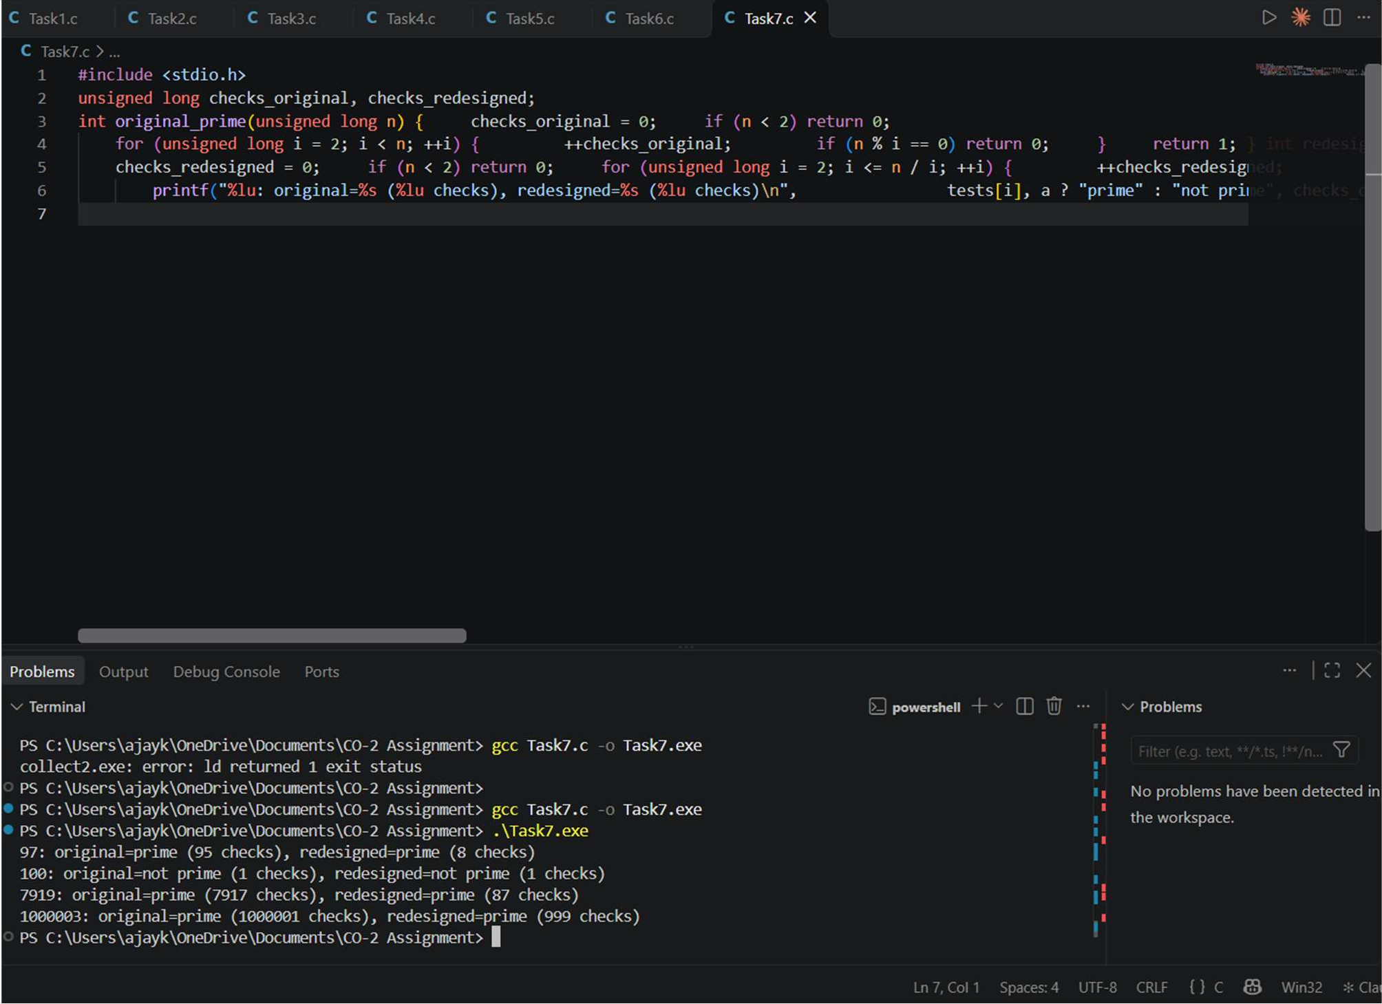

Analysis / Discussion
The bottleneck is the divisor-testing loop. For a large prime, the original version tests nearly every number from 2 to n-1, so the number of modulo operations grows linearly with n. The redesigned version checks only up to the square root, so the work grows approximately with √n. The objective is measurable: preserve the same prime/non-prime answer while reducing the number of divisions. The redesign uses no additional array or dynamic memory; it needs only a loop variable and counter. Its trade-off is a slightly less obvious loop condition, so the mathematical reason should be documented. Using `i <= n / i` avoids overflow from `i * i`. For the example inputs, the original method will make many more checks for prime values, while the redesigned counts are 8, 1, 87 and 999 respectively. Actual original counts should be taken from the program run on the student's compiler.

Alternative Concept and Complexity Analysis
A sieve is another redesign if the system checks a large number of ticket values up to a known maximum. It uses O(N) memory and O(N log log N) preprocessing, then answers each prime query in O(1). The square-root method uses O(1) extra space and is better for a small number of isolated queries. The redesign is therefore selected according to workload rather than claiming one method is always best.

Result
The selected redesign removes unnecessary divisor checks while keeping the same output. It is suitable for individual ticket checks and provides a clear improvement in time complexity without extra array storage.

